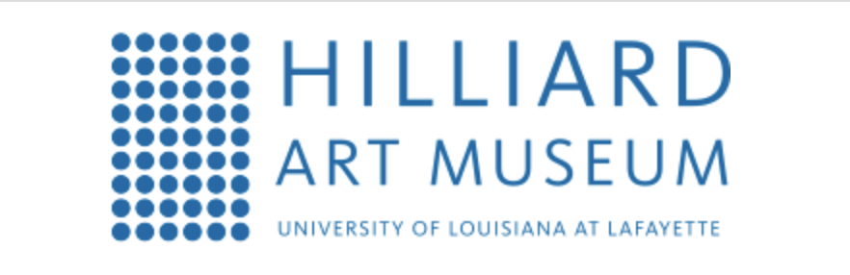
For Release
Oct. X, 2022

Media contact:
Joelle Polisky, 615-516-0358
Email: jpolisky@goshiftkey.com

*** MEDIA ADVISORY ***

Ring in the holiday shopping season at
Hilliard Art Museum’s Jingle Bell Market
WHAT:
Get all of your holiday shopping done and support the arts at the annual Jingle Bell Market! Vendors from across Louisiana will be in attendance. Shoppers can enjoy 10% off their purchase at the Museum store, free admission to the museum, hot cocoa and cookies. Free gift-wrapping will be available on all purchases.

To add to the holiday cheer, Lafayette Ballet Theatre dancers will be a part of the art, posing in the gallery in their Nutcracker finery.

WHO: General public and media are invited to attend

WHEN: Saturday, Dec. 3 – 10 a.m. – 5 p.m.

WHERE: 710 East St. Mary Boulevard, Lafayette, LA 70503

LIVE: Media is invited to attend

About Hilliard Art Museum:
Our Museum is a bridge. Our Museum is a catalyst. Our Museum is for everyone. We connect art and education, our university and our community, generations and cultures. The Hilliard Art Museum-University of Louisiana at Lafayette is not just a place to look at art. It’s a place where visitors are encouraged to truly see art. It is a place of learning, where students sketch in the galleries and artists talk about their work. It’s a destination for families, where kids express their own creativity through hands-on activities. And it’s a resource for academic research and observation. Museum experiences build skills that extend into every aspect of life. Viewing art promotes dialogue and understanding between individuals, among families, and throughout our community. Art makes life richer. And better. For everyone.

###

