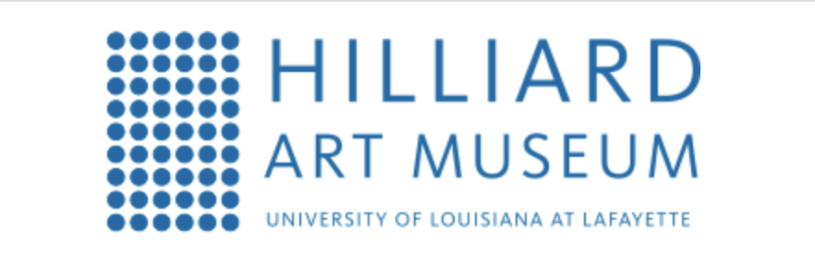
For Release
February X, 2023

Media contact:
Joelle Polisky, 615-516-0358
Email: jpolisky@goshiftkey.com

HILLIARD ANNOUNCES THREE UPCOMING EXHIBITIONS BY FEMALE ARTISTS COMING THIS SPRING

Lafayette, LA – The Hilliard Art Museum will bring Women’s History Month into the present beginning March 3 with a new exhibition by Luciana Abait, a California-based, Argentinian born artist who explores the impact of climate and the environment on migration and planetary survival, including a moving photo series of Lake Powell, a reservoir that provides water and hydroelectric power to millions in the southwestern U.S.

Luciana Abait: On the Verge features more than 20 recent artworks spanning photography, painting, sculpture, video installation and augmented reality that demonstrate the powerful visual language for which Abait is known. The exhibition, which premiered at Loyola Marymount University’s Laband Art Gallery, is one of three upcoming exhibitions by female artists. Entanglement: New Work by Kalee Appleton opens March 21 followed by Yeon Choi: My Favorite Things on April 15.

“I find that Luciana’s depictions of our contemporary climate crisis are likewise
overwhelming and invitational,” said Laband Art Gallery Director Karen Rapp, who curated the exhibition.“ Her palette is sometimes skewed neon and deliberately unnatural which causes an unsettling effect. But, at the same time, she renders her pictures with such intentionally beautiful surfaces and colors to remind us of what is at stake: her landscapes are figuratively pushing at the edge of planetary existence. It’s as if she’s urging us to step into the scene and do something good.”

“We invite you to the Hilliard not only to enjoy beautiful new works by female artists but also to spark new ideas and possibilities through the questions the installations provokes,” says Hilliard Director LouAnne Greenwald. “Entanglement, a new mixed media exhibition asks you to consider the dualities of the virtual and natural worlds, while My Favorite Things, a new painting exhibition of domestic and organic objects ilicits contemplation of the seen and unseen with visual representations of artist Yeon Choi’s emotions.”

UPCOMING EXHIBITIONS AT HILLIARD

LUCIANA ABAIT: ON THE VERGE
DATE: March 3 – July 29, 2023
This survey exhibition of the artist’s work of the last half-decade presents more than 20
pieces in diverse media. With her distinctive and powerful visual language, Argentinian-
born and Los Angeles-based Luciana Abait addresses climate change, environmental
fragility and perils, and their impact on global migration and planetary survival. The
exhibition originated at the Laband Art Gallery, Loyola Marymount University.

ENTANGLEMENT: NEW WORK BY KALEE APPLETON
DATE: March 21 — July 15, 2023
This body of work blurs the line between drawing, sculpture and photography, while challenging the traditions of conventional photography through exploration of materiality and technique. This work explores the complicated relationship of society and the land by displaying visual platitudes of idealized depictions of landscapes and floral elements. By controlling and restricting the physical frame to a gesture, a mark reminiscent of a Photoshop post-production brush stroke, digitally manipulated landscape imagery and floral imagery is manifested into a physical object that wavers from a flat 2D photograph to a 3D object. The unframed pieces are results of a smart algorithm, content awareness, designed to fill an empty space with that of the imagery in which it surrounds. Together, these pieces examine the digital nature of the altered photographic landscape as a repeated or obviously falsified image. This digital-ness is transferred to the physical realm through the display within irregularly shaped wooden frames that contradict the materiality of what is typically associated with a solid wooden structure and creates a sense of cohesion between natural and virtual motifs.

YEON CHOI: MY FAVORITE THINGS
DATE: April 15 — July 1, 2023
These paintings of domestic and organic objects collectively represent the dualities and dialectics of the artist’s emotions and experiences—attraction and aversion, hope and despair, delight and disgust—and her efforts to incorporate all of these lived experiences and their visual representations.

OTHER UPCOMING EVENTS:
CREATIVE CONVERSATION: BRIAN SCHNEIDER
DATE: Wed, Feb 15 • 6pm—7pm
Artist Brian Schneider discusses Be Still, a light installation on the façade of the Hilliard Art Museum. Guests will enjoy the opportunity to contemplate and meditate together on the messages projected as Psalm 46:10 is progressively unveiled.

CREATIVE CONVERSATION: YEON CHOI
DATE: Wed, Apr 5 6 pm-7pm
Artist and Professor in the UL College of Art, Yeon Choi, discusses her work in the exhibition, Yeon Choi: My Favorite Things.

CREATIVE CONVERSATION: KALEE APPLETON
DATE: Wed Apr 19 6pm-7pm
Artist Kalee Appleton discusses her work in the exhibition, Entanglement.

LET'S MAKE ART

DATE: Third Saturday of Every Month 10:00 AM -12:00 PM

Free with Admission
The Hilliard Art Museum is excited to offer monthly drop-in art making on the third Saturday of each month from 10 am-12 pm. Work with a local teaching artist to create an artwork inspired by the museum's current exhibitions. Art activities are designed for ages 4 and up. Children must be accompanied by an adult. Participation is free with admission.

EXHIBITION PUBLICATION:
Envisioning the South: The Roger Houston Ogden Collection
Essays by Benjamin M. Hickey and John R. Kemp
Retail price: $29.95

This publication will document the exhibition Envisioning the South: The Roger Houston Ogden Collection presented at the Hilliard Art Museum – University of Louisiana at Lafayette from January 20 – August 19, 2023 including reproductions of approximately fifty works of art on loan from Mr. Ogden’s private art collection as well as from the Ogden Museum of Southern Art.

Roger Houston Ogden is the foremost collector of Southern Art and founder of the Ogden Museum of Southern Art in New Orleans.

This book will relay the collector’s journey from his first purchase of a painting by renowned landscape artist, Alexander Drysdale to his turn toward abstraction inspired by the work of artist Ida Kohlmeyer, and then to photography with the acquisition of work by Clarence John Laughlin. Ogden’s collection is undeniably important in that it has come to define Southern art.

Museum Hours, Admission & General Information
The Hilliard Art Museum is located at 710 E. Saint Mary Blvd. on the campus of the University of Louisiana at Lafayette. Museum hours are Tuesday through Friday, 9 a.m.-5 p.m.; Saturday, 10 a.m.-5 p.m.; closed Sunday and Monday. For general information, please visit HillliardMuseum.org or call 337-482-2278.

Upon request, press and media kits are available that include additional high-resolution images and selected literature.

About the Hilliard Art Museum
Our Museum is a bridge. Our Museum is a catalyst. Our Museum is for everyone. We connect art and education, our university and our community, generations and cultures. The Hilliard Art Museum-University of Louisiana at Lafayette is not just a place to look at art. It’s a place where visitors are encouraged to truly see art. It is a place of learning, where students sketch in the galleries and artists talk about their work. It’s a destination for families, where kids express their own creativity through hands-on activities. And it’s a resource for academic research and observation. Museum experiences build skills that extend into every aspect of life. Viewing art promotes dialogue and understanding between individuals, among families, and throughout our community. Art makes life richer. And better. For everyone.

LINKS TO IMAGES HERE

###

